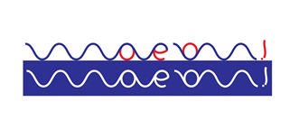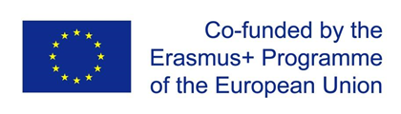

MOVE-ON!
DISSEMINATION AND EXPLOITATION PLAN
„PROMOTING SOCIAL INCLUSION OF WOMEN, AGED OVER 50, LOW-QUALIFIED, UNEMPLOYED, AND DEVELOPING EDUCATORS’ PROFILE THROUGH EDUCATION BY ART“, „MOVE-ON!“, No 2018-1-PT01-KA204-047314

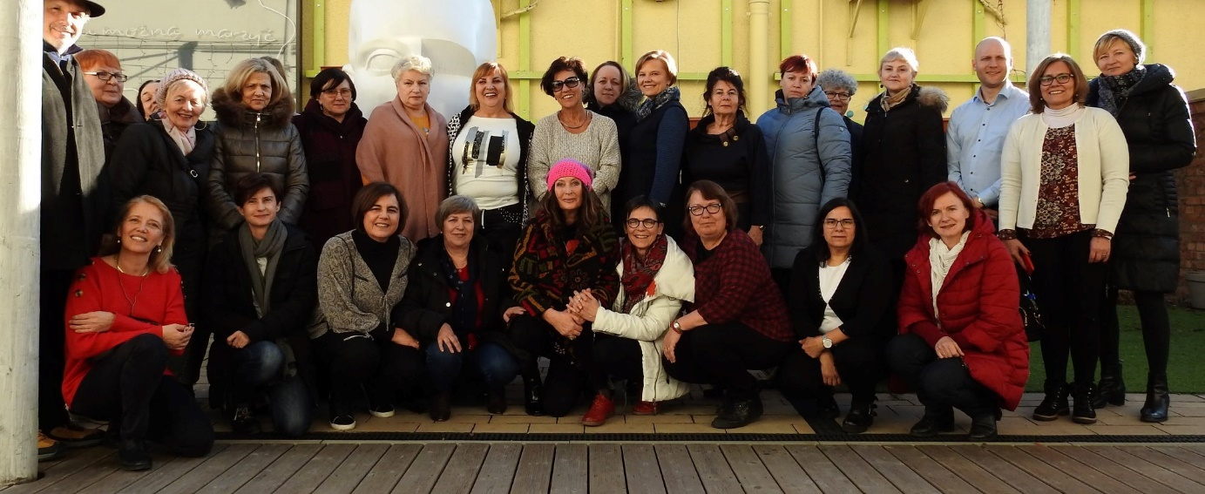

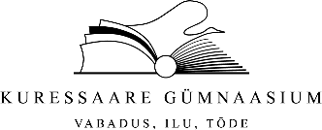

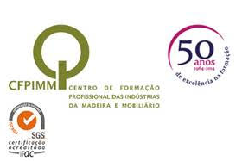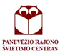
INDEX

1. Introduction 3
2. Requirements in terms of dissemination and exploitation 3
3. What, why, who, when, where and how 5
4. Aims and objectives 7
5. Sharing project results 8
6. Target audiences 9
7. Tools 9
7.1. Internal communication 10
On the other hand, regular meetings of project management are another means of communication between members and, finally the tools of telecommunication (phone, email, systems of video conferencing, etc.). 10
7.2 Dissemination tools 10
7.2.1. Logo 10
7.2.2. Website 10
7.2.3. Social Network 10
7.2.4. Poster and brochure 10
7.2.5. Newsletters 11
8. Partners commitment 11

- Introduction
Activities serving the dissemination and exploitation of results are a way to showcase the work that has been done as part of the Erasmus+ project. Sharing results, lessons learned and outcomes and findings beyond the participating organisations will enable a wider community to benefit from a work that has received EU funding, as well as to promote the organisation’s efforts towards the objectives of Erasmus+, which attaches fundamental importance to the link between Programme and policies. Therefore each of the projects supported by the Programme is a step towards achieving the general objectives defined by the Programme to improve and modernise education, training and youth systems.
Dissemination activities will vary between projects, and it is important to consider what kinds of dissemination activities are fitted to each participating organisations. Partners in smaller projects should undertake dissemination and exploitation appropriate to the level of their activity. Dissemination activities for a mobility project will trigger different requirements than those for a partnership project. The extent of dissemination and exploitation activities will increase with the size and strategic importance of the project. When applying, applicants will be asked to explain their intentions/plans for dissemination and exploitation activities, and if successful, required to carry them out.

- Requirements in terms of dissemination and exploitation

General qualitative requirements
Depending on the action, applicants for funding under Erasmus+ are required to consider dissemination and exploitation activities at the application stage, during their activity and after the activity has finished. This section gives an overview of the basic requirements laid down in the official documentation of the Erasmus+ Programme.
Dissemination and exploitation is one of the award criteria on which the application will be assessed. Depending on the project type, it will be given a different weight in the assessment of the application. For cooperation projects, a detailed and comprehensive plan, describing targets, tools and outcomes will be requested and further assessed. Although generally one partner will take the responsibility for dissemination and exploitation coordination for the whole project, the responsibility for implementation should be shared among all partners. Each partner will be involved in these activities according to the needs and roles in the project.

Visibility of the European Union and of the Erasmus+ Programme
Beneficiaries shall always use the European emblem (the 'EU flag') and the name of the European Union spelled out in full in all communication and promotional material. The preferred option to communicate about EU funding through the Erasmus+ Programme is to write 'Co-funded by the Erasmus+ Programme of the European Union' next to the EU emblem. Examples of acknowledgement of EU funding and translations of the text are available at eacea.ec.europa.eu/about-eacea/visual-identity_en.
The brand name of 'Erasmus+' shall not be translated. Guidelines for beneficiaries on the use of the EU emblem in the context of EU programmes are available at ec.europa.eu/dgs/communication/services/visual_identity/pdf/use-emblem_en.pdf

Use of the Erasmus+ Project Results Platform
An Erasmus+ Project Results Platform was established to offer a comprehensive overview of projects funded under the Programme and to highlight good practice examples and success stories. The platform also makes available products/deliverables/intellectual outputs which are the result of the projects funded.
Good practice examples are the object of an annual selection by each National Agency and by the Executive Agency. Success stories are selected from among the good practice examples at central level by DG EAC.
The Erasmus+ Project Results Platform serves different purposes:
- Transparency, as it provides a comprehensive overview of all projects funded under the programme (including project summaries, funding figures, URL links, etc.);
- Accountability, as it gives access to end-users and practitioners to project results;
- Inspiration, as it showcases good practices and success stories among Erasmus+ beneficiaries selected every year at national and European level.
For most Erasmus+ projects, beneficiaries are required to provide a summary describing their project in English at application stage.
The project summary is of particular importance as it provides a description for the general public. It should therefore be drafted in plain language and clear style so that the actual content of the project can be quickly understood, also by outsiders.
The following elements should be part of the summary: context/background of the project; objectives of the project; number and profile of participants; description of activities; methodology to be used in carrying out the project; a short description of the results and impact envisaged; the potential longer-term benefits.
The Erasmus+ Project Results Platform can be consulted at: ec.europa.eu/programmes/erasmus-plus/projects/.

- What, why, who, when, where and how

What do dissemination and exploitation mean?

Dissemination is a planned process of providing information on the results of programmes and initiatives to key actors. It occurs as and when the result of programmes and initiatives become available. In terms of the Erasmus+ Programme this involves spreading the word about the project successes and outcomes as far as possible. Making others aware of the project will impact on other organisations in the future and will contribute to raising the profile of the organisation carrying out the project. To effectively disseminate results, an appropriate process at the beginning of the project needs to be designed. This should cover why, what, how, when, to whom and where disseminating results will take place, both during and after the funding period.
Exploitation is (a) a planned process of transferring the successful results of the programmes and initiatives to appropriate decision-makers in regulated local, regional, national or European systems, on the one hand, and (b) a planned process of convincing individual end-users to adopt and/or apply the results of programmes and initiatives, on the other hand. For Erasmus+ this means maximising the potential of the funded activities, so that the results are used beyond the lifetime of the project. It should be noted that the project is being carried out as part of an international programme working towards lifelong learning and supporting European policies in the field of education, training and employment. Results should be developed in such a way that they can be tailored to the needs of others; transferred to new areas; sustained after the funding period has finished; or used to influence future policy and practice.
Dissemination and exploitation are therefore distinct but closely related to one another.

What is intended by "results of the activity"?

Results are achievements of the European activity or project that received EU funding. The type of result will vary depending on the type of project. Results can be classified as either (a) outputs or (b) outcomes:
Output: a tangible product which is produced by a given project and which may be quantified; outputs can be accessible products like curricula, studies, reports, materials, events, or websites;
Outcome: an intangible added value achieved through the achievement of the project objectives and targets. Ordinarily, such added value defies quantification, whether it covers concrete events and actions such as training, training platforms, content or methodology, or more abstract consequences such as increased awareness, increased skills or improved abilities. Knowledge and experience gained by participants, partners or other stakeholders involved in the project.

What do impact and sustainability mean?

Impact is the effect that the activity carried out and its results have on people, practices, organisations and systems. Dissemination and exploitation of results plans can help to maximize the effect of the activities being developed so that they will impact on the immediate participants and partners for years to come. Benefits to other stakeholders should also be considered in order to make a bigger difference and get the most from the project.
Sustainability is the capacity of the project to continue and use its results beyond the end of the funding period. The project results can then be used and exploited in the longer-term, perhaps via commercialization, accreditation or mainstreaming. Not all parts of the project or results may be sustainable and it is important to view dissemination and exploitation as a progression that extends beyond the duration of the project, and into the future.
- Aims and objectives
The first goal of dissemination and exploitation is to spread projects' results. The second goal is to contribute to the implementation and shaping of national and European policies and systems. Beneficiaries should develop their own way of achieving this goal. Developing ideas for dissemination and exploitation is important for every project funded by the Erasmus+ Programme. However, the type and intensity of dissemination and exploitation activities should be proportional and tailored to particular needs and type of project developed. This includes whether the project is process-oriented or aimed at producing tangible deliverables; if it is stand alone or part of a larger initiative; whether it is developed by large or small-scale participating organisations, etc. Participating organisations should discuss the aims and objectives of the activities/plan and decide on the best activities and approaches as well as share the tasks among partners taking into account the particular specifics of the project.
For structured cooperation projects such as Strategic Partnerships, Knowledge Alliances, Sport, Collaborative Partnerships and Capacity-building projects, a good quality dissemination and exploitation plan should include measurable and realistic objectives, a detailed timetable and provide a resource planning for the activities to be undertaken. Involving target groups in activities will also help to maximize the use of the project’s results. It is important to set the strategy right from the beginning as this is the main way that will foster communication with the target audiences. Such a requirement is not foreseen for mobility projects. However, project organizers are invited to communicate the learning outcomes reached by participants in such activities. They should also encourage participants to share with others what they have gained from taking part in the mobility activity. Finally, the dissemination part of the Programme is also supposed to raise the quality of the Programme by stimulating innovative projects and sharing good practices.
Communication is a broader concept. It includes information and promotion activities to raise awareness and enhance the visibility of the project’s activities in addition to the dissemination and exploitation of the project results. However, very often it is difficult to make a clear distinction between these areas. For this reason, planning an overall strategy framework covering both fields can be a more efficient way to make the most of the available resources. Dissemination and exploitation of results should form a crucial part of any communication activities taking place during the project’s lifetime.
- Sharing project results
Taking the time to develop a comprehensive dissemination and exploitation plan will be advantageous for both the beneficiary and its partners. As well as raising the profile of the organisation, dissemination and exploitation activities can often create new opportunities to extend the project and its results or develop new partnerships for the future. Successful dissemination and exploitation may also lead to external recognition of the work carried out adding further credit to it. Sharing the results will enable others to benefit from the activities and experiences of the Erasmus+ Programme. Project results can serve as examples and inspire others by showing what is possible to achieve under the Programme.
Dissemination and exploitation of project results can help to inform future policy and practice. Dissemination and exploitation of results activities carried out by beneficiaries will support the wider aim of improving the European Union’s systems. The impact of the Erasmus+ Programme is measured not only by the quality of project results but also by the extent to which these results are known and used outside the project partnership. By reaching out to as many potential users as possible through effective dissemination, this will help to achieve a return on investment.
The dissemination and exploitation of project results also increases awareness of the opportunities offered by the Programme and highlights the European added value of activities supported by Erasmus+. This can contribute to a positive public perception and encourage wider participation in this new EU Programme. It is fundamental to consider the aims and objectives of the dissemination and exploitation plan. These should link to the project aims to ensure that the methods and approaches used are appropriate for the Erasmus+ project and its results, as well as for the identified target audiences. Dissemination and exploitation goals may be to:
- raise awareness;
- extend the impact;
- engage stakeholders and target groups;
- share solutions and know how;
- influence policy and practice;
- develop new partnerships.
- Target audiences
Identifying target groups, both at different geographical levels (local, regional, national, European) and in the own field of the beneficiary (colleagues, peers, local authorities, other organisations leading the same type of activity, networks, etc.) is essential. Activities and messages have to be tailored appropriately taking into account audiences and target groups, for example:
- End-users of the project activities and results: adult education organizations, local authorities and local associations, universities, local employers, learners and their families.
- Stakeholders, experts or practitioners in the adult education and/or in Education by Art;
- Decision-makers at local, regional, national and European level;
- Press and media.
- Tools
There are many different ways to disseminate and exploit results. Being creative and thinking of fresh ideas so that the Erasmus+ project and results really stand out will be appreciated. Beneficiaries will use:
- the Erasmus+ Project Results Platform;
- project website;
- transnational meetings;
- dedicated discussion opportunities such as information sessions, workshops, (online) seminars, training activities, exhibitions, demonstrations, or peer reviews;
- targeted written material such as reports, newsletters, press releases, leaflets or brochures;
- social media;
- public events;
- project branding and logos;
- existing contacts and networks.
In terms of exploitation it is important to think about how results can make a difference to the project, end- users, peers or to policy makers. Exploitation mechanisms include:
- positive reputational effects for the participating organisations;
- increased awareness on a theme, target or area of work;
- increased influencing on policy and practice.
7.1. Internal communication
In order to improve communication between partners, an intranet on the website of the project will be enabled with the following tools of management and exchange of information:
- Enabled and secure access for each partner;
- Sharing documents – partners can upload and download documents;
- Access to updated planning and management documents.
On the other hand, regular meetings of project management are another means of communication between members and, finally the tools of telecommunication (phone, email, systems of video conferencing, etc.).
7.2 Dissemination tools
7.2.1. Logo
The project partners have decided to design a logo of the common project, which must be always accompanied by the own Erasmus +.

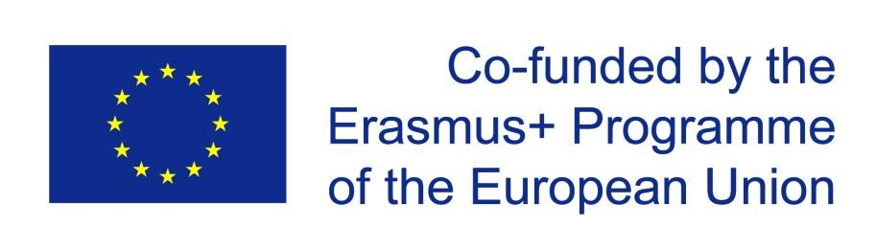
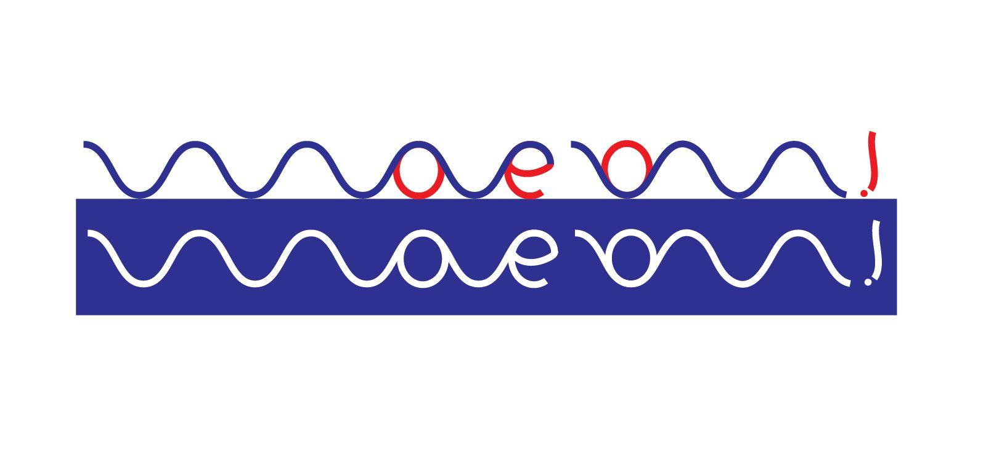

7.2.2. Website
The web will have a public side which will include different sections with different information: Executive summary of the project, project objectives, results and progress made, identification of the National Agency, information of partners, primary contact for the project, etc.
The web adress is http://moveonproject.eu/

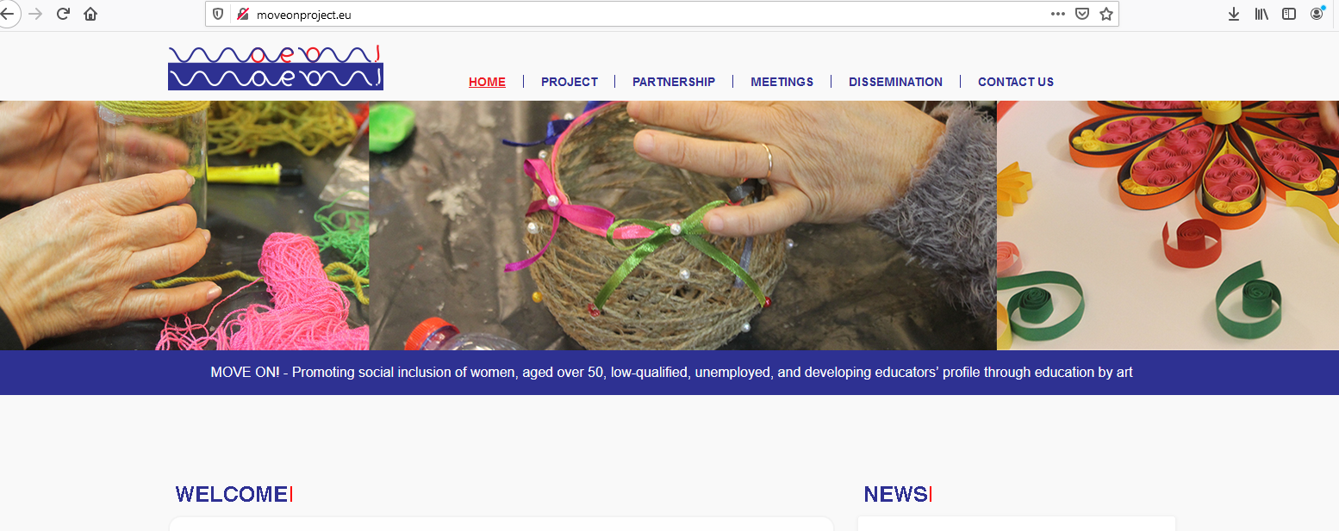

7.2.3. Social Network
Among the partners, Civil Vállalkozások Egyesület will take care of dissemination through social network: Facebook.

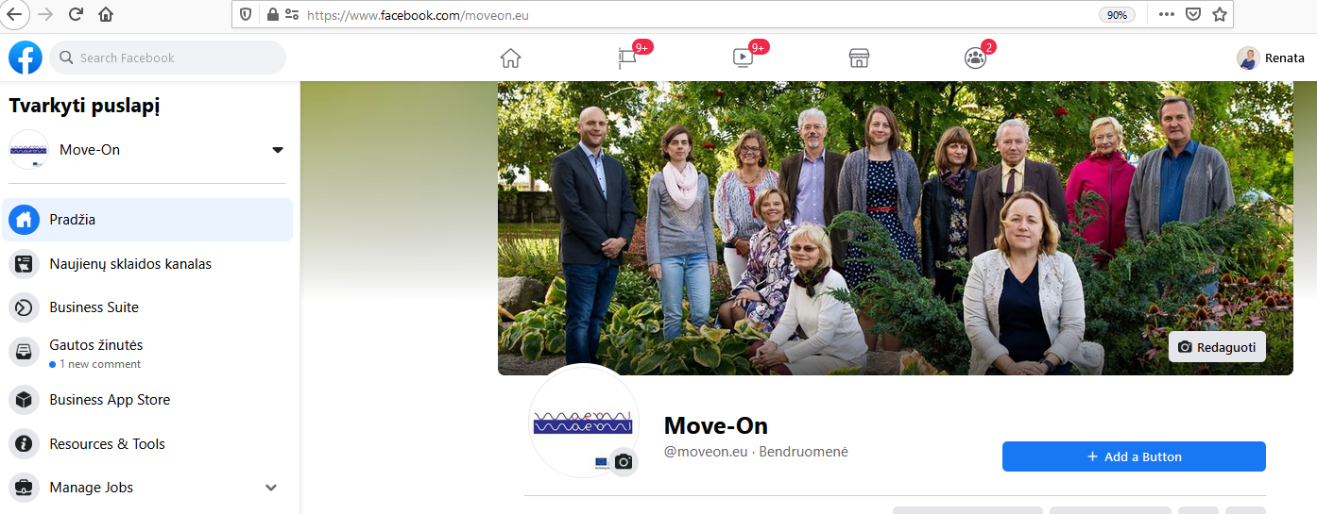
7.2.4. Poster and brochure
A poster for dissemination and a brochure created by Kuressaare Gümnaasium.

7.2.5. Newsletters
After each meeting, the coordinator of the project, will create a newsletter. They will be uploaded in the website: http://mkt.cfpimm.pt or http://moveonproject.eu/ .

- Partners commitment

Partners commit to disseminate along the project:
8.1. CFPIMM
TOOLS | PLANNING
Website | http://cfpimm.pt/parcerias_03.asp
Newsletters | https://bit.ly/31OTcKA  https://bit.ly/2IwnWJ0  https://bit.ly/2N1k5HV  http://mkt.cfpimm.pt/vl/9fd3890fe8538f89-d1fd733c3d2c379466ca8-34ecFe0emyNe  http://mkt.cfpimm.pt/vl/d20a826be180-96fb49f62a2-3955d615c22f86-defze8GqtemyNe6584af2b34
Magazines | https://issuu.com/home/published/vm_32_13.12.2018  https://issuu.com/home/published/valormadeira33_abril_2019  https://cfpimm.pt/valormadeira_34/  https://cfpimm.pt/valormadeira_35/  https://cfpimm.pt/valormadeira_36/  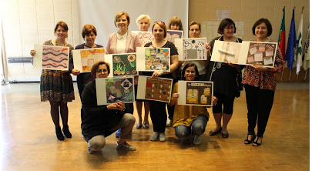
Press releases
Seminars | Seminar Education by Art (Eunice macedo, CFPIMM, 26/03/2019)  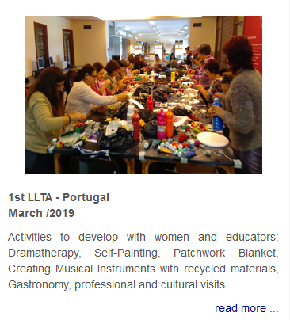  Seminar Bibliotherapy (Sirlene Cristófono, CFPIMM, 27/03/2019)
Workshops
…

8.2. KURESSAARE GUMNAASIUM
TOOLS | PLANNING
Website | Project information Kuressaare Gymnasiums website: https://www.oesel.ee/osilia/?s=6
Newsletters | -
Magazines | The news in electronical newspaper Meie KG about the project meeting in Estonia https://www.oesel.ee/meiekg/index.php
Press releases
Seminars | Seminar for adult educators:  Introduction of the project and survey among adult educators on the 22nd of October 2018, total participants 12 educators;  Seminars (2 seminars) for Women 50+:  Introduction of the project and survey among women 50+ during October and November 2018, total participants 11 women;
Workshops | Pottery workshop for adult educators “Art as teaching method” - https://www.facebook.com/KGOsilia/posts/1024770071065261  The results of pottery workshop: https://www.facebook.com/KGOsilia/posts/1035629823312619
Social media | 2nd LTTA in Gdansk post in Facebook: https://www.facebook.com/KGOsilia/posts/1291347291074203  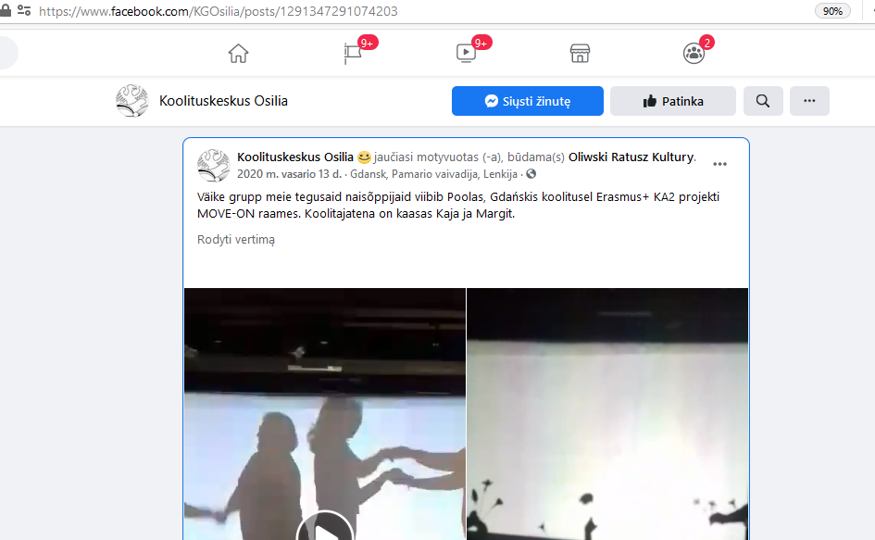  Transnational meeting in Estonia: post in Facebook https://www.facebook.com/KGOsilia/videos/397705317602326/  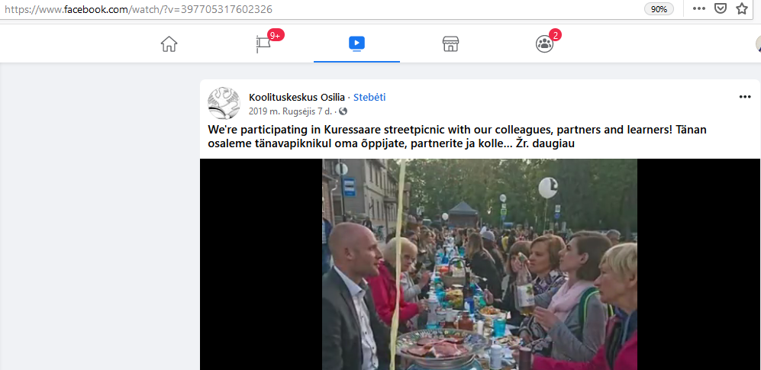  Transnational meeting in Estonia, post in Facebook: https://www.facebook.com/KGOsilia/posts/1153331164875817
8.3. CIVIL VALLALKOZASOK EGYESULET
TOOLS | PLANNING
Website | www.civilvallalkozasok.hu www.civicenterprises.org
Newsletters | Civic Enterprises Annual Report 2019  Survey for Senior Adults October, 2018  Senior Mentor Program Tool kit 2021
Magazines | https://civicenterprises.org/index.php?menu=kiir&id=111
Press releases | https://civicenterprises.org/index.php?menu=kiir&id=118  Partnership with Budapest International Documentary Film Festival and Mover-On! Participants
Seminars | Nov 9, 2018 - Seminar about “Minimally Invasive Education” for Woman 50+  Oct 1, 2018 - Seminar about “Social Capital, the power of networks” for Women 50+  Feb 15, 2019 - Debate “IQ is largely a pseudoscientific swindle” for Women 50+  Mar 8, 2019 - Seminar about “Importance of art and music in Education” for Woman 50+  location H-1024 Budapest, Millenáris park Building D  Aug 28, 2020 Year Opening Walk Walk with Seniors at Margaret Island, Budapest  Group discussion about Budapest International Documentary Film Festival  speaker: Szilveszter Zalai  Dec 4, 2020 Mikulas Walk with Seniors at Margaret Island, Budapest  Group discussion about Antifragility based on latest publications of Nassim Taleb  Jan 8, 2021 First Walk with Move-On! Participants at Gellért Hill, Budapest  Group Discussion about Oswald Spengler’s Theory of The Decline of the West
Workshops | September 9, 2018 - First Team Meeting of year 2018/2019  Sep 20, 2018 - Reading Group: Disinformation (Mihai Pacepa)  Dec 2, 2018 - Reading Group: The Square and the Tower Networks and Power, from the Freemasons to Facebook  location H-1024 Budapest, Millenáris park Building D  June 19, 2019 - Closing Workshop of year 2018/2019  location Centrál Kávéház Budapest  April 8, 2020 Zoom meeting title: The Silent City -Move-On! program during Wuhan Virus
Social media | https://www.facebook.com/civicenterprises.org/  https://www.facebook.com/moveon.eu/  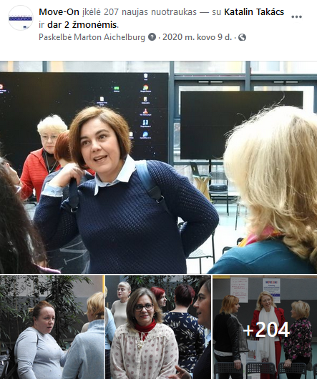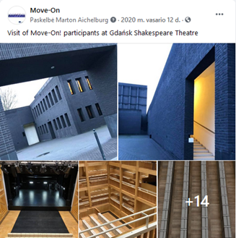

8.4. PANEVEZIO RAJONO SVIETIMO CENTRAS
TOOLS | PLANNING
Website | Project dissemination, PRSC website http://www.prsc.lt/lt/?option=com_content&view=article&id=328:move-on&catid=20:projektai  http://www.prsc.lt/lt/neformalusis-vaiku-svietimas/19-naujienos-2016-m/2016-2017/299-issukiai-darbscioms-ir-kantrioms-lietuvos-penkiasdesimtmetems  http://www.prsc.lt/lt/neformalusis-vaiku-svietimas/19-naujienos-2016-m/2016-2017/290-pirmasis-tarptautinio-erasmus-ka2-programos-projekto-move-on-susitikimas  http://www.prsc.lt/lt/neformalusis-vaiku-svietimas/19-naujienos-2016-m/2016-2017/333-projekto-move-on-dalyviu-kurybiskumas  http://www.prsc.lt/lt/neformalusis-vaiku-svietimas/19-naujienos-2016-m/2016-2017/341-menas-is-sirdies  Project dissemination, Panevezys district municipality website:  http://www.panrs.lt/go.php/lit/Issukiai-darbscioms-ir-kantrioms-Lietuvos-penkiasdesimtmetems  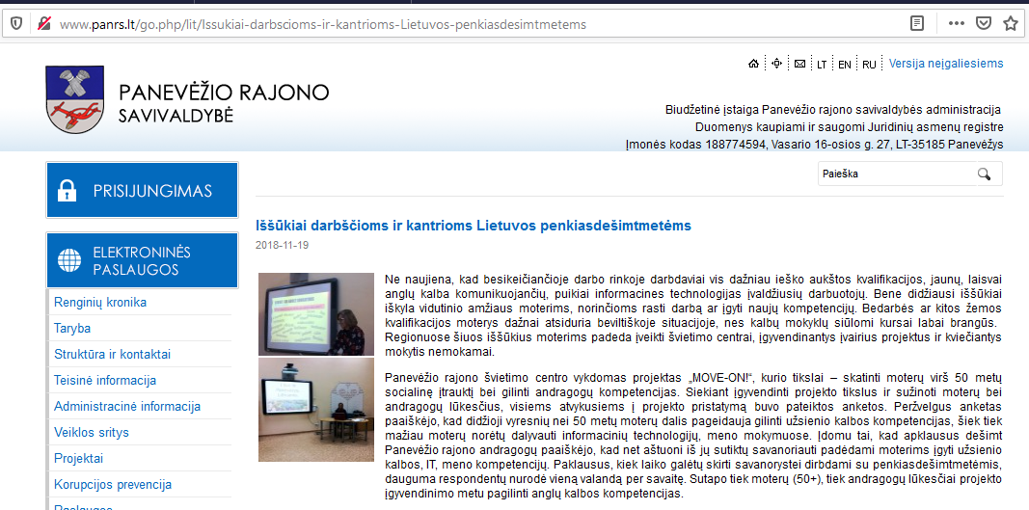  http://www.panrs.lt/go.php/lit/Menas-is-sirdies  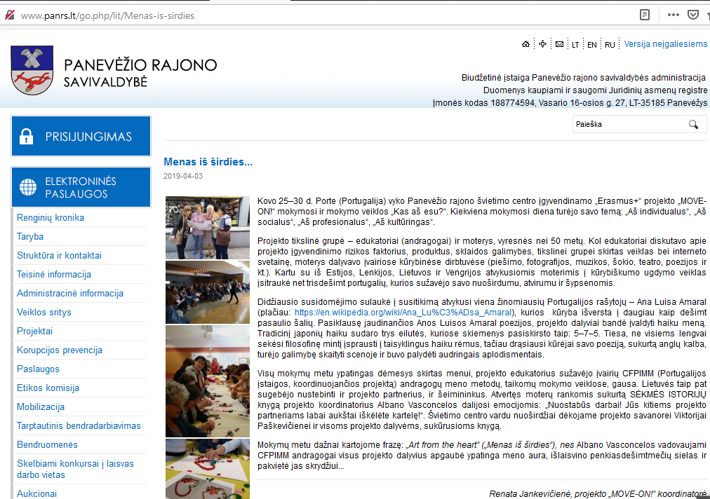  Project dissemination EPALE:  https://ec.europa.eu/epale/lt/content/ar-galima-ismokyti-zmones-spindeti  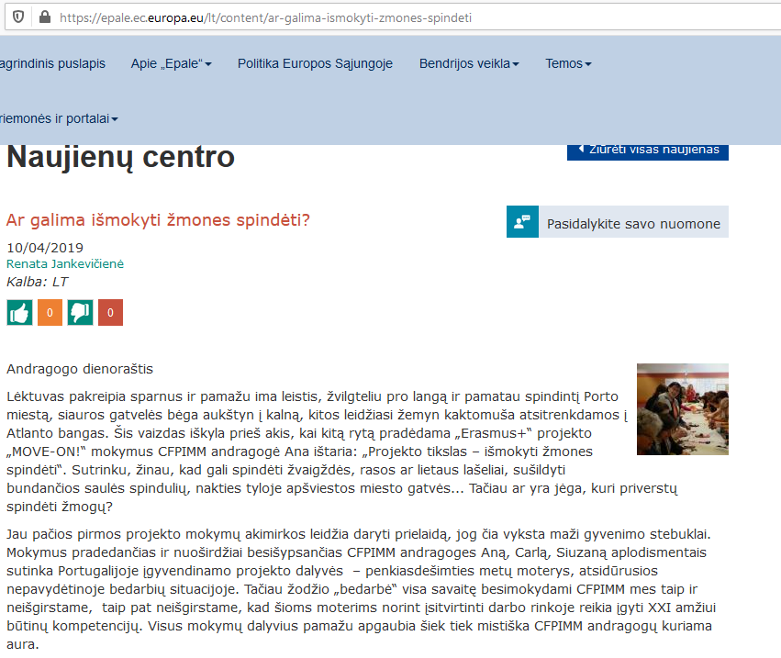  https://epale.ec.europa.eu/lt/blog/kaip-svietimas-mena-gali-keisti-gyvenima  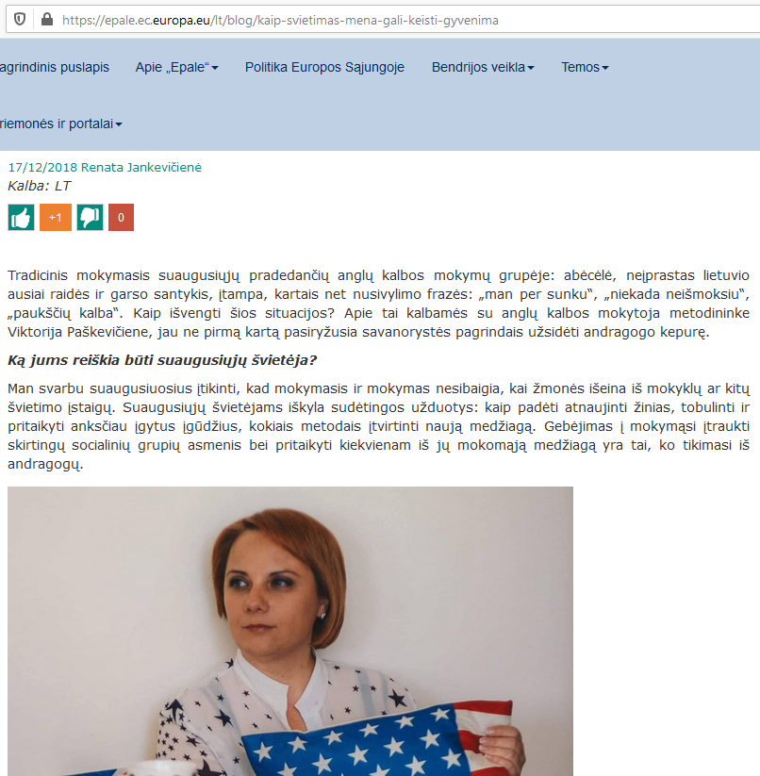  https://ec.europa.eu/epale/lt/content/issukiai-darbscioms-ir-kantrioms-lietuvos-penkiasdesimtmetems  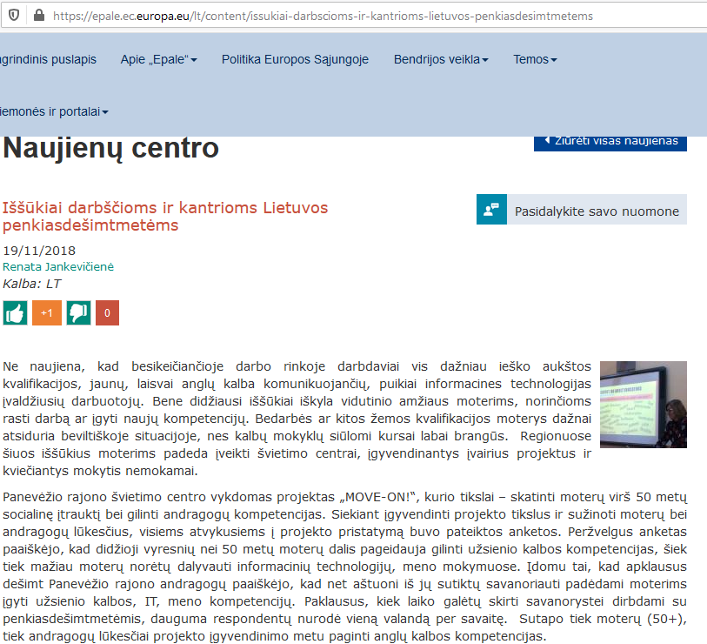  https://epale.ec.europa.eu/lt/content/mokymasis-polonezo-ritmu  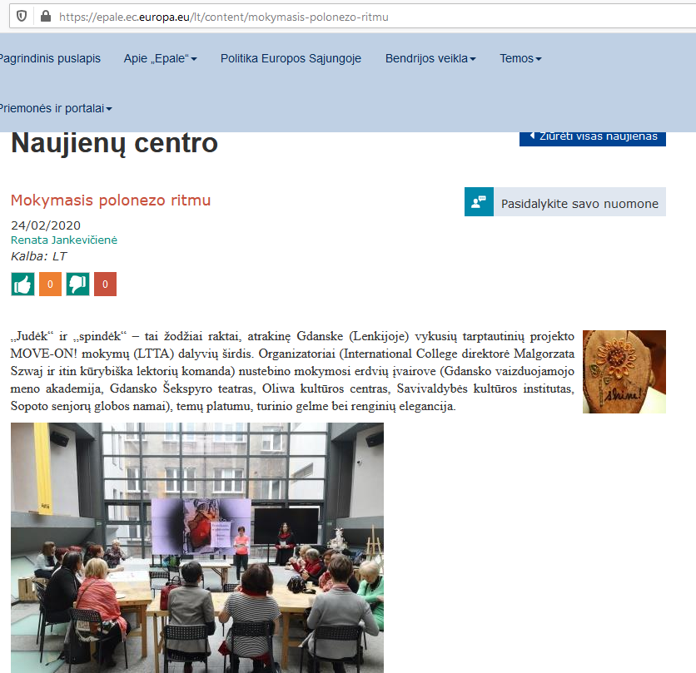  https://epale.ec.europa.eu/lt/content/kaip-islipti-dezutes  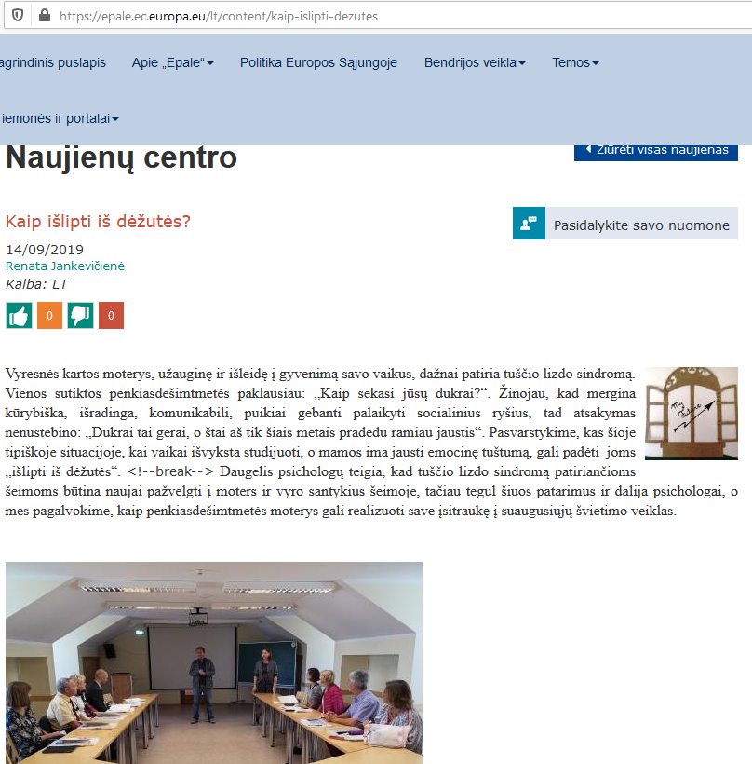  Project dissemination PRSC Facebook:  https://www.facebook.com/prsc.lt/photos/pcb.2549482135081739/2549474361749183/?  type=3&theater  https://www.facebook.com/prsc.lt/photos/a.696309937065644/2495407663822520/?  type=3&theater  https://www.facebook.com/prsc.lt/photos/a.696309937065644/2473405659356054/?  type=3&theater  https://www.facebook.com/prsc.lt/photos/a.696309937065644/2464744893555464/?  type=3&theater  https://www.facebook.com/prsc.lt/photos/pcb.2342825515747403/2342823032414318/?  type=3&theater  https://www.facebook.com/prsc.lt/posts/2337124982984123?__tn__=K-R
Newsletters
Magazines
Press releases
Seminars | Seminars for adults. English through art:  English language for beginners, 40 hours (Anglų kalbos mokymai pradedantiesiems, programs, No. 221000504)  English language for advanced, 40 hours (Anglų kalba pažengusiesiems, program No. 221000503)  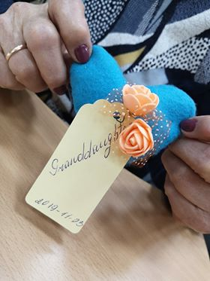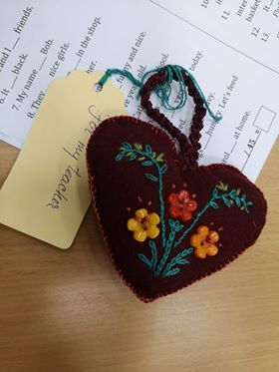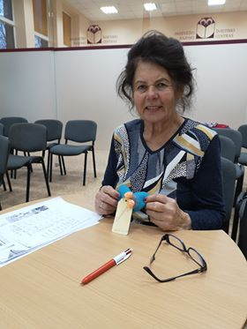  http://www.prsc.lt/lt/component/events/?view=event&id=950  http://www.prsc.lt/lt/component/events/?view=event&id=951
Workshops | LTTA (PORTUGAL)
Dissemination events | EPALE event:  https://ec.europa.eu/epale/lt/content/neformaliojo-suaugusiuju-svietimo-atspalviai-0  PRSC projects dissemination event:  http://www.panrs.lt/go.php/lit/Renginys-Neformaliojo-suaugusiuju-svietimo-atspalviai  Project dissemination event: http://prsc.lt/lt/component/events/?view=event&id=855  06-09-2018, Panevezys district sports teachers, meeting, 15 participants  12-09-2018, Panevezys district foreign languages teachers, meeting, 25 participants  13-09-2018, Panevezys district history and geography teachers, meeting, 15 participants  21-09-2018, Meeting with stakeholders from Lithuania, 30 participants  21-09-2018, Panevezys district Lithuanian language teachers, meeting, 25 participants.  24-09-2018, Panevezys district primary teachers, meeting, 30 participants.  25-09-2018, Panevezys district technology teachers, meeting, 25 participants.  26-09-2018 Video conference „Komunikacijos tiltai“ participants, 16 participants  26-09-2018, Meeting with stakeholders from Lithuania, 10 participants  27-09-2018, Panevezys district classroom teachers, 12 participants  09-10-2018, Panevezys district pre-primary teachers meeting, 20 participants  12-10-2018, Panevezys district arts teachers meeting, 10 participants  15-10-2018, International meeting, 15 participants from Bulgaria  17-10-2018, Panevezys district schools deputy directors meeting, 20 participants  28-05-2019, Erasmus+ project OUR DIGI SPACE first meeting in Ankara, 12 participants

8.5. “ENGLISH UNLIMITED” Sp.zo.o/ “INERNATIONAL COLLEGE” sp. z o.o.
TOOLS | PLANNING
Website | Project dissemination on www.eu.com.pl and www.icollege.com.pl
Newsletters | EU Magazine and https://www.facebook.com/InternationalCollege3city/
Seminars | Seminar for adult educators:  Introduction of the project and survey among adult educators on November 16th 2018, total participants 5 educators;  Seminars (3 seminars) for Women 50+:  Introduction of the project and survey among women 50+ in November and December 2018, total participants 20 women  Informal meetings and presentations of the ideas from LTTA1 with female volunteers 50+ working with senior citizens through art techniques, Senior Care Home in Sopot; April 30th, 2019;
Dissemination events | The presentations were aimed at adult education organizations, local authorities , universities, stakeholders, experts or practitioners in the adult education and/or in Education through Art as well as decision-makers at local and regional levels.  Presentation of the project idea on October 1st 2019 at Oliwa Hall of Culture in Gdańsk, 4 participants, https://www.ratuszkultury.pl/?jezyk=en,,  Presentation of the project on November 26th, 2019 at The Baltic Sea Cultural Centre, 3 participants, https://www.nck.org.pl/en  Presentation of the project on December 4th 2019 at the Academy of Fine Arts 3 participants, https://en.asp.gda.pl/  Presentation of the project on December 5th2019 at the Gdańsk Shakespeare Theatre 2 participants, https://teatrszekspirowski.pl/en/  Presentation of the project on December 12th 2019 at the Gdańsk City Cultural Institute 3 participants, http://ikm.gda.pl/en/  Presentation of the project on January 17th 2020 at the Gdańsk Academy of Music, 2 participants, https://www.amuz.gda.pl/  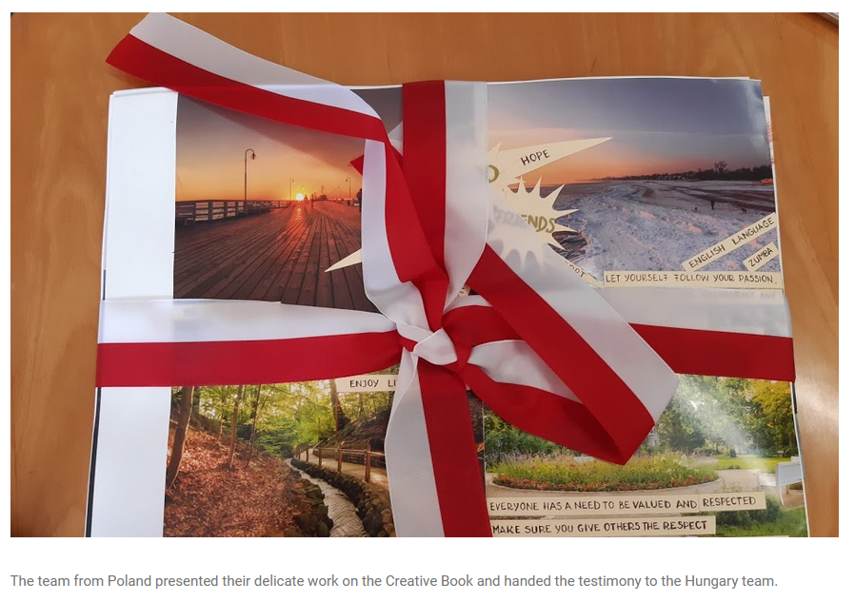

The Meeting in PRSC

